Interactive Story Board

Setup and troubleshooting guide

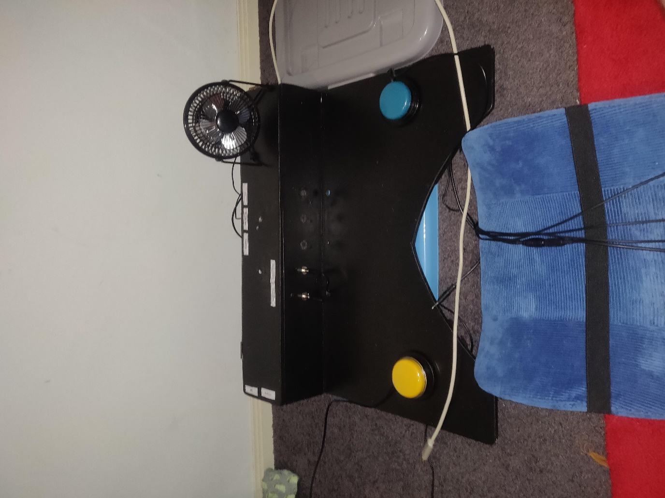

Contents

Overview of included components 3

The Board 3

Switches 4

Fan Output 5

Vibration Mat 5

Adjustable Wheelchair Clamps 6

Powerlink Box Connector 6

USB Charging Cable 7

Board Setup Instructions 7

Game Options and Configuration 9

Switches 10

Speed 10

Story 10

Text 11

Page Turn 11

Shutdown 11

Turning Off the ISB 11

Charging the ISB 12

Appendices 13

Appendix A 14

Appendix B 15

# 

# Overview of included components

Listed below are all components required to fully use the interactive story board (ISB). Pictures of each component will also be included to serve as a visual guide throughout the setup process. These parts have all been included in the handover for the project – and where relevant specifications will be given to aid in replacement of any parts.

## The Board

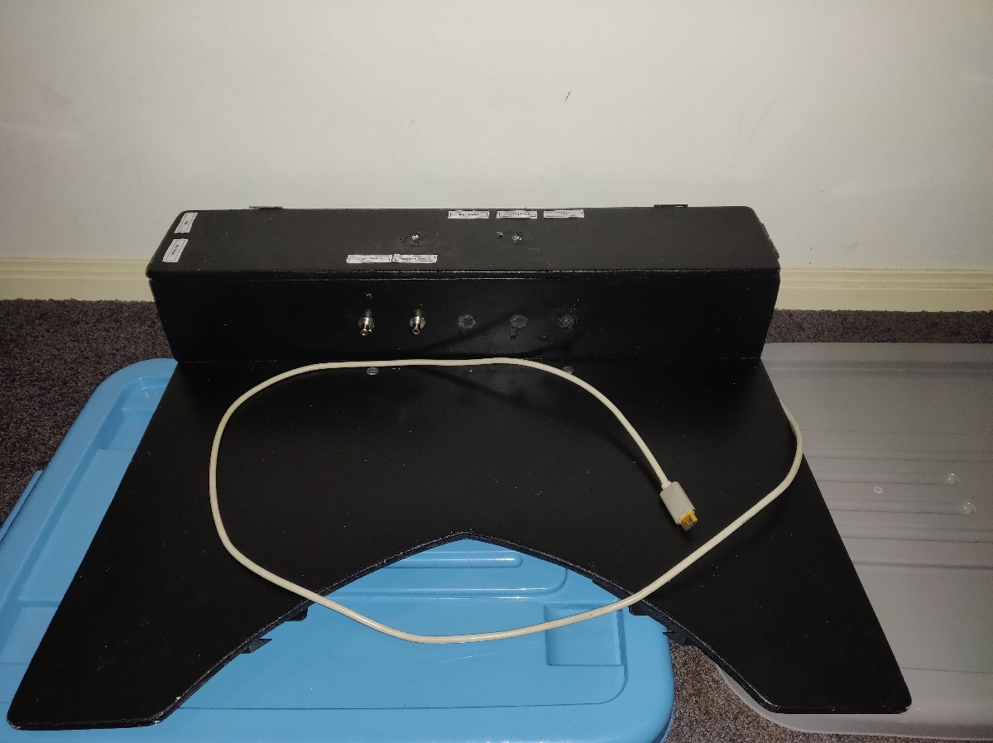

This is the main component of the ISB and is the ‘brains’ of the whole project. Notable parts of the board are the battery bank (located under the lid on the right-hand side), and a grey HDMI cable that is to be plugged into any speaker equipped projector, monitor or TV.

## Switches

The project also requires a minimum of 1 switch to function (in single switch mode). These switches are the only way to interact with the ISB.

## Fan Output

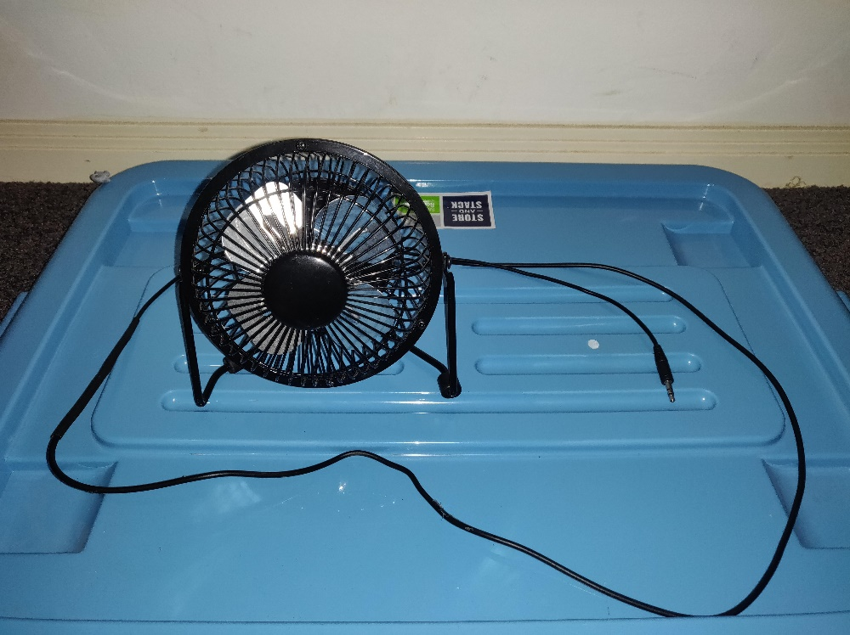

A 5V DC (USB) fan has been modified to allow for connections via 3.5mm audio jack. This fan is turned automatically on when relevant to the story to provide physical feedback.

## Vibration Mat

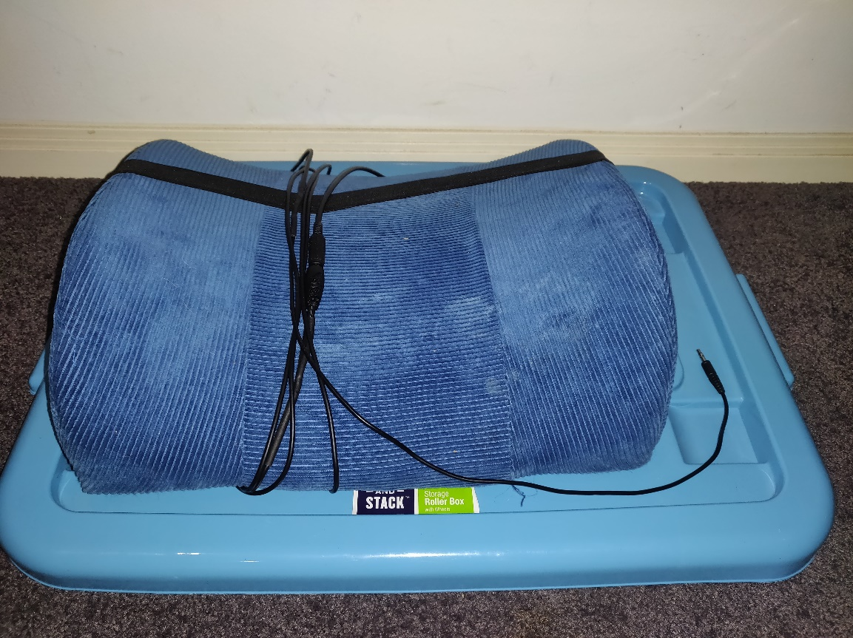

A vibration mat is included with the project. Similarly to the fan it has been modified to have a 3.5mm audio jack output for connection to the board.

## Adjustable Wheelchair Clamps

2 custom 3D printed wheelchair clamps have been designed to allow for the ISB to be attached to students’ wheelchairs of varying widths. These clamps are can be removed – further clarification will be provided in setup section. The model file for these clamps will be included in handover documentation if replacements are required.

## Powerlink Box Connector

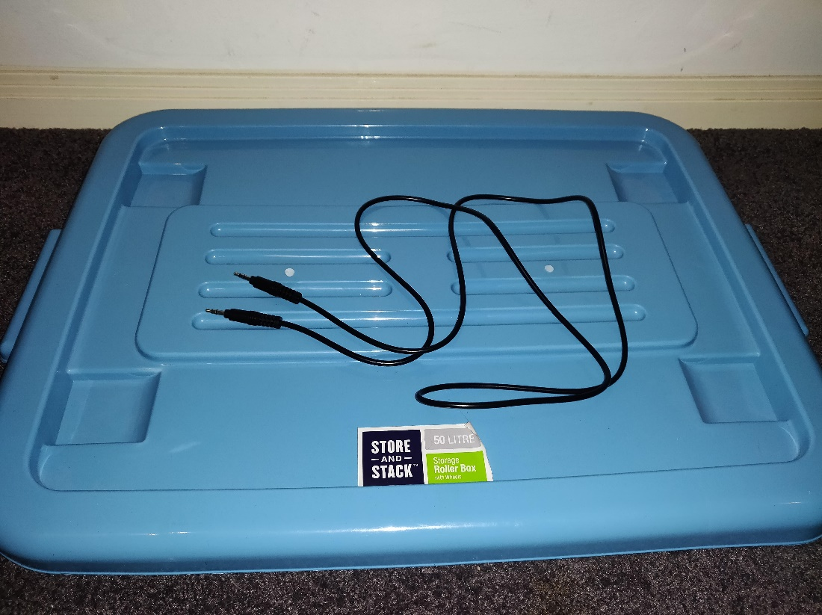

To give extra variety for teachers/students the ISB can interface with a Powerlink Box. For this a standard 3.5mm male-to-male audio cable is used

## USB Charging Cable

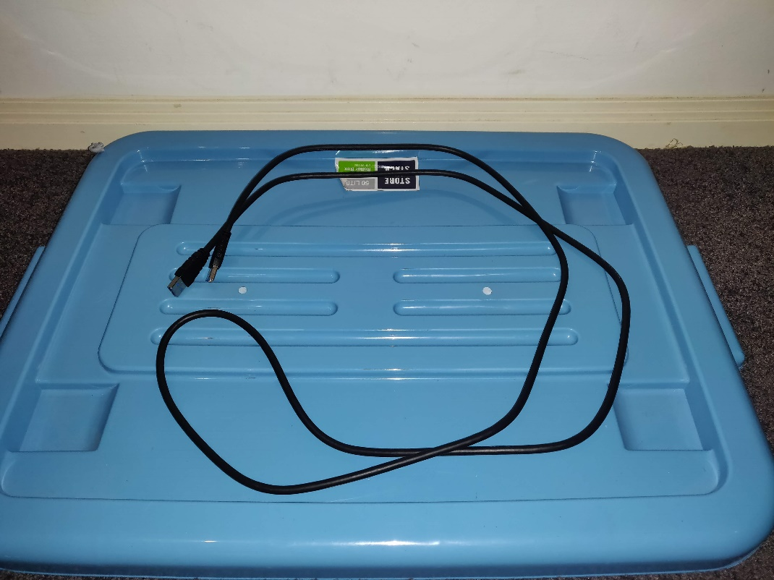

A male-to-male USB A charging cable is included for charging the battery in the board. A Standard phone charging wall connector is required for charging and is not included.

# Board Setup Instructions

1. If attaching the board to a student’s wheelchair follow the below steps.
   1. Slide the clamps onto the rails located on the underside of the board from the outer edges, put clamps in open position by pulling red lever up
   2. Position the claps as wide as possible and place the board on the student’s wheelchair arm rests, ensuring that the board is close to centre on the wheelchair.
   3. Slide the clamps inwards until they are touching the arm rests, pull the red lever down to lock clamps into position (see appendix 1 for picture)
   4. Carefully let go of the board and give a slight shake to ensure solid attachment to wheelchair
2. Plug in any switches to be used in the provided connections located on the front of the board. If wires are an issue, there is a hole located just under the connections that wires can be routed through to reduce clutter.

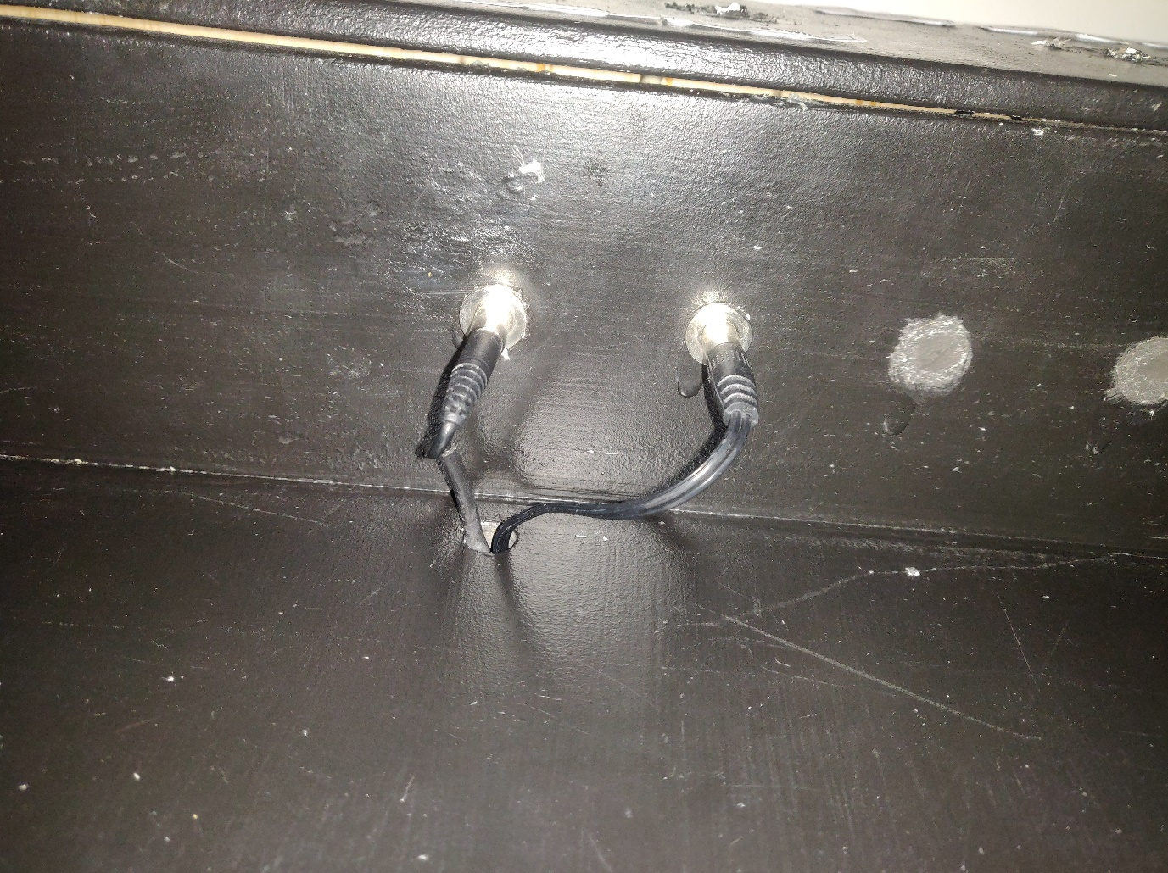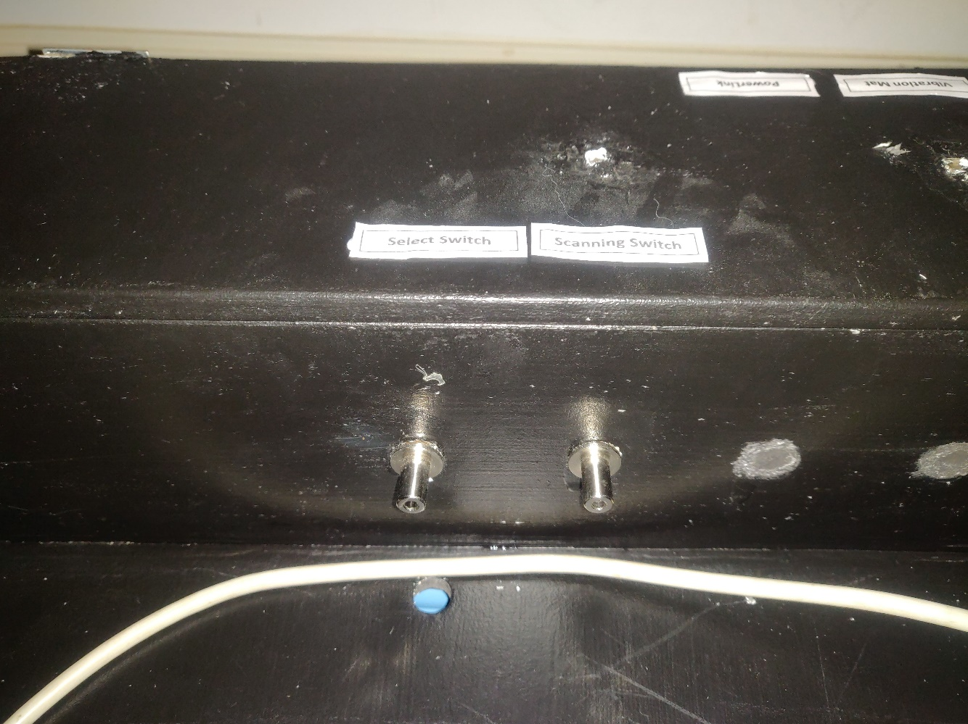

1. Plug in the fan, vibration mat, and optional PowerLink cable to the output connections located on the back of the board

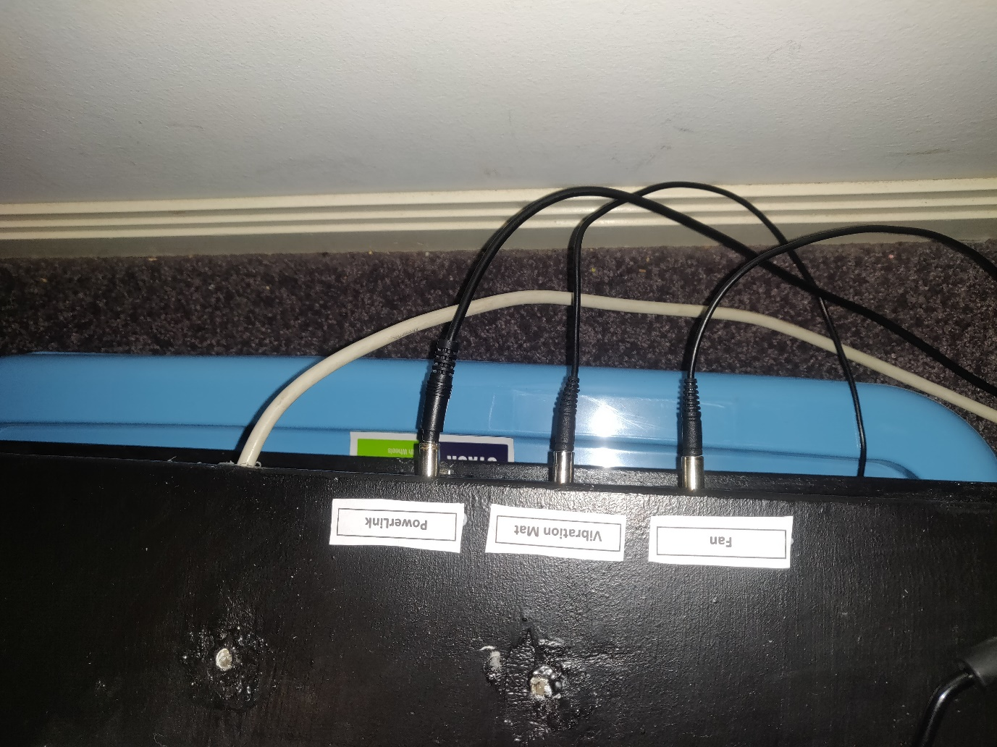

1. Follow steps in other section for configuring the Powerlink box
2. Plug in grey HDMI cable to the projector, Monitor, or TV that is being used to play the game. Audio is also output over the HDMI cable, so ensure the device that is being connected has speakers included or attached.
3. Open the lid for the board by undoing the latch on the right-hand side. On the right-hand side there is battery, press and hold the button located on the end of the battery bank under the 4 dots. Once the dots light up, release the button and close the lid/latch.

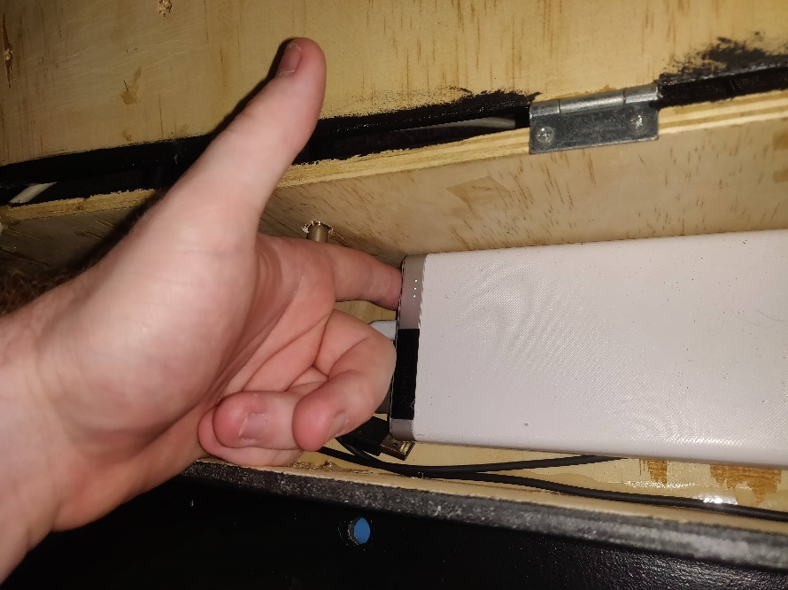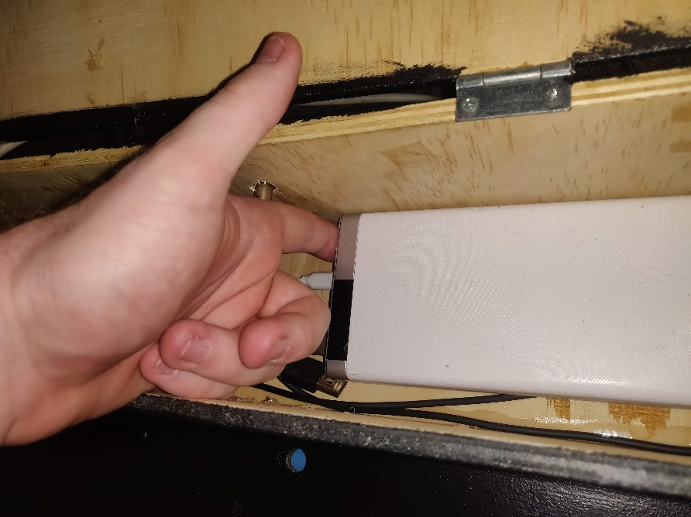

# Game Options and Configuration

This section outlines the options and their effects on the ISB. By default the story is playable straight away without touching the options as it begins with default values. However, further customisation to fit student needs and increase engagement is possible through the options menu.

To Access the options menu, press the selection switch when ‘Options’ is scanned on the main menu

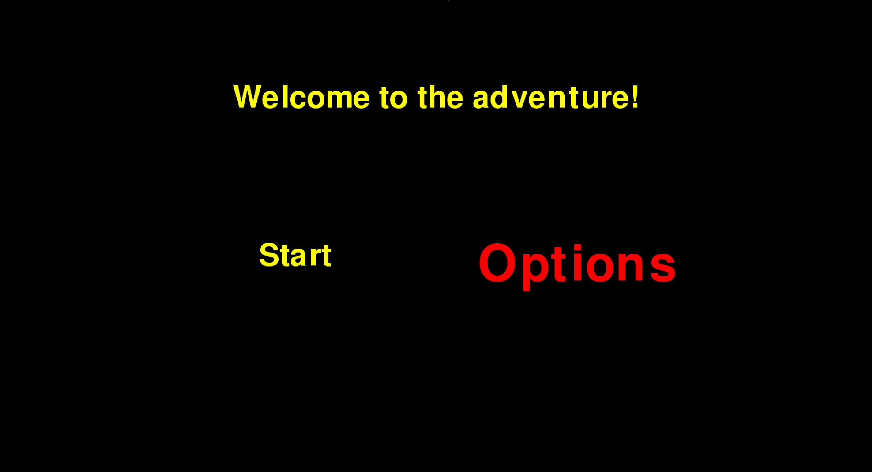

Once in the options menu there are several different settings that can be changed, these include switches, speed, story, text, turn page and shutdown shut down. These options are further discussed below. The default settings for each will be noted highlighted in **BOLD**

## Switches

The switch options allow for the game to be changed from a single switch (with automatic scanning) method of play to a dual switch (additional switch is used for manual scanning) option.

**1 Switch: Automatic scanning and only a switch used for selecting**  
 2 Switch: One switch for selection, one switch for scanning

## Speed

The speed options allow the automatic scanning speed to be adjusted to each students’ needs. The times are represented in seconds and have no effect if in 2 switch mode.

Slower: Increases scanning delay by +1 second  
 **Default: Reset scanning speed to default of 4 Seconds** Faster: Decrease scanning speed by 0.5 seconds

## Story

The story options allow for the story to be customised. The game allows for a choice between 2 interchangeable narratives for the beginning, middle, and end of the story (allowing for up to 6 unique story combinations). An outline of these story options can be seen in appendix B for reference.

An outline will only be given for the beginning options, as changing the middle/end works the exact same. Default values for all story options are randomly generated when the ISB is powered on.

Beginning: Allows for customisation of beginning of story

Option 1: Set story beginning to first narrative option

Option 2: Set story beginning to second narrative option

## Text

Allows for increasing of the text size within the game. Increasing text size may cause text overlapping or clipping off the screen.

**Default: 100% text size**Bigger: 130% text size  
Biggest: 160% text size

## Page Turn

Allows for different options for the “turn page” between each scene in the story

**Default: page turn between each question page. Will not change pages until student hits selection switch**

Both Switches: Same as default page but page can be turned with either selection or scanning

Auto 10s: Same as default, except page will automatically turn after 10 seconds

No Page: Next page is removed fully; story pages will be consecutive.

## Shutdown

Allows for computer to be shut down safely.

# Turning Off the ISB

1. Press the shutdown button located on the left-hand side of the board OR navigate to the shutdown option in the settings menu
2. Wait 20-30 seconds to ensure device is fully shutdown
3. Like powering on the device, open the lid then press and hold the power button located on the battery bank until the dots go dark





# Charging the ISB

1. Turn off ISB following the instructions outlined above
2. Plug in one end of the provided USB cable to the USB port on the back of the board (under the outputs)
3. Plug the other end of the cable into any Phone charger
4. Press the shutdown button

# Configuring Powerlink box

1. Setup Powerlink just like its about to use a switch
2. Set Powerlink to ‘direct’ mode
3. Plug in other end of audio cable that is connected to the board’s “powerlink” output into the switch location on the Powerlink

# Troubleshooting

## Battery lights are on but there is no output on display

This is an issue caused by the battery bank, it is a cheap one that the previous teams must have bought. Sometimes the battery bank stays on but does not power the computer, and it usually happens after charging the device.

To fix this issue the following steps can be used

* Long press the power button on the battery bank until the lights in the dots go out
* Press the power button on the battery bank until the dots light up

## No output from the fan

* Check the switch on the back of the fan is in the on position
* Check connections inside the board for any disconnections

## Vibration mat is not working or is weak

* Check connections between mat and board
* Biggest end of the Cable must attach into the mat, smallest into the output from board
* Replace batteries located in the vibration mat

## PowerLink Output does not work

* Check all connections on Powerlink
* Is the Powerlink in direct mode? Is it connected correctly?
* Pull the switch connection on the Powerlink out very slightly. Some cables fit a little bit weirdly
* Inspect connections inside box for obvious disconnections.

## Device has frozen during playing of the game

This is a limitation of the battery bank once again. In very rare circumstances it can not provide enough power to the computer and it crashes. This is also made worse if the battery bank is low on power.

* To immediately fix the issue, long press the power button on the battery bank to turn device off, press again to turn it on
* If issue continues stop using the device and put it on charge until at least ¾ dots are illuminated

## Game crashed and now a desktop is displayed

Although we have tested the game as much as possible, we are sure there are some errors we have missed. If this occurs, follow the steps below to restart the device.

* Long press the power button on the battery bank until the lights in the dots go out
* Press the power button on the battery bank until the dots light up
* Note what caused the error (e.g. changing scanning time while in 2 switch mode) and avoid doing it again. If the project is still ongoing make note of the problem for the current team to fix.

## I can hear the vibration pads in the board vibrating, but the board has minimal vibration.

The Glue holding the vibration pads onto the board has probably broken over time. These things really vibrate and its likely that the glue will give eventually. To fix this you could

* Open the board and look for 3 small circles (~1cm diameter) floating around the box
* If they are not glued to the walls of the box anymore apply some superglue and put them back on

# Appendices

## Appendix A

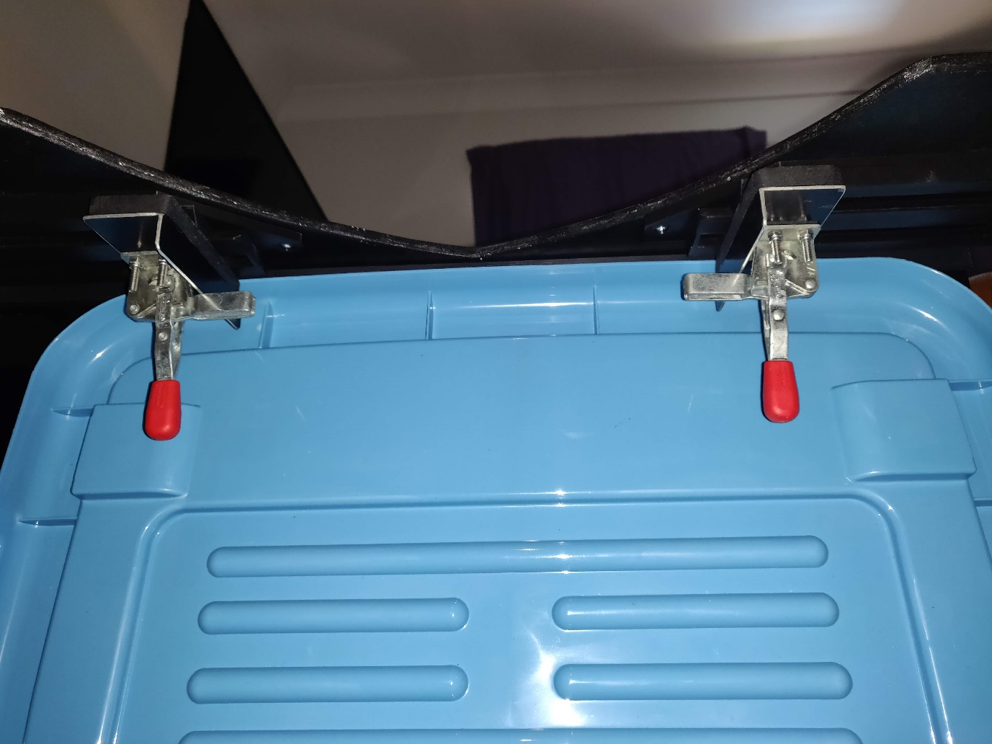

## Appendix B

|  |  |  |  |  |  |  |  |  |  |
| --- | --- | --- | --- | --- | --- | --- | --- | --- | --- |
| Beginning | | | | | | | | | |
| Option 1 | | | | | Option 2 | | | | |
| Page 1: My story is about a … | | | | | Page 1: My story is about detective … | | | | |
| Baby | Alien | Dragon | Princess | Scientist | Fairy | Cat | Monster | Robot | Prince |
| Dog | Fox | Pirate | Giant | Spider | Possum | Butterfly | Teacher | Wizard | Donkey |
| Page 2: And their friend…. | | | | | Page 2: And their sidekick... | | | | |
| Tiger | Chef | Dinosaur | Cowboy | Ghost | Fireman | Bear | Cow | Knight | Superhero |
| Clown | Policeman | Turtle | Pig | Spaceman | Magician | Giraffe | Witch | Rat | Builder |
| Page 3: They are going on an adventure to the…. | | | | | Page 3: They have a problem… They are looking for a lost… | | | | |
| Castle | Playground | Beach | Zoo | Clouds | Harp | Lunch | Puppy | Key | Money |
| Space | Volcano | Farm | Hospital | Haunted house | Necklace | Bag | Wheelchair | Tooth | Book |
| Page 4: The weather is…. | | | | | Page 4: They get ready by packing a bag with a | | | | |
| Sunny | Stormy | Rainy | Cloudy | Windy | Magnifying glass | Rope | Switch | Ipad | Tissues |
| Hot | Dry | Cold | Warm | Snowy | Map | Phone | Toothbrush | Pen | First aid kit |
| Page 5: So they put on their …. | | | | | Page 5: Where will they start looking, they will go to….. | | | | |
| Coats | Sunglasses | Hat | Scarf | Second skin | Shops | Light house | Grandma’s house | River | Top of the beanstalk |
| Rain boots | Tutu | Scary mask | Cape | Swimmers | Farm | Island | Movies | School | Jungle |
| Middle | | | | | | | | | |
| Page 6: They are ready to travel in their…. | | | | | Page 6: They are ready to travel in their… | | | | |
| Spaceship | Train | Dodgem car | Jet ski | Bus | Helicopter | Racing car | Scooter | Unicycle | Aeroplane |
| Boat | Wheelchair | Taxi | Car | Hot air balloon | Pirate ship | Truck | Digger | Time machine | Motor bike |
| Page 7: They go through the…. | | | | | Page 7: They go through the…. | | | | |
| Mirror | Tunnel | Storm | Forest | Window | Toilet | Darkness | Curtains | Bushes | Water |
| Door | Fence | River | Mud | Fire | Cave | Sand | Cupboard | Slime | Pit |
| Page 8: It is….. | | | | | Page 8: It is…. | | | | |
| Fluffy | Cold | Scary | Wet | Smooth | Hard | Heavy | Sticky | Hot | Lumpy |
| Loud | Scratchy | Bumpy | Light | Gross | Rough | Stretchy | Quiet | Dark | Freezing |
| Page 9: They stop for a…. | | | | | Page 9: They stop to look with their spotlight….. | | | | |
| Drink | Nap | Stretch | Read a book | Chocolate Cake | Here | There | Under | Over | Up |
| Go to the toilet | Make a phone call | Scratch | Listen to music | Ask for directions | Down | Across | Left | Right | Around |
| Page 10: They then go over a ….. | | | | | Page 10: They then go up, up, up ….. | | | | |
| Pedestrian crossing | Bridge | Stepping stones | Train track | Rainbow | Ladder | Stairs | Mountain | Rope | Vine |
| Fence | Plinth | Drain | Hill | Speed bump | Pole | Elevator | Escalator | Hoist | Tree |
| End | | | | | | | | | |
| Page 11: It is… | | | | | Page 11: It is … | | | | |
| Hard | Heavy | Sticky | Hot | Lumpy | Fluffy | Cold | Scary | Wet | Smooth |
| Rough | Stretchy | Quiet | Dark | Freezing | Loud | Scratchy | Bumpy | Light | Gross |
| Page 12: They meet someone who helped…a | | | | | Page 12: They finally find something that helps…it is a | | | | |
| Elephant | Mermaid | Friend | Kangaroo | Crab | Treasure | PODD book | Tamborine | Spell book | Crown |
| Unicorn | Stuntman | Werewolf | Spider | King | Brother | Letter | Secret | Queen | Nurse |
| Page 13: They are…. | | | | | Page 13: It is | | | | |
| Fat | Clever | Mad | Sleepy | Gross | Stinky | Funny | Silly | Cool | Good |
| Mean | Cheeky | Crazy | Naughty | My Favourite | Beautiful | Smart | Shinny | Bad | Annoying |
| Page 14: Our trip took…. | | | | | Page 14: Our trip took…. | | | | |
| 100 years | 2 days | 5 minutes | 25 seconds | All day | 5 hours | A day | A year | 4 days | A long time |
| All night | A month | A minute | A little while | Forever | Half an hour | 10 seconds | Some time | A week | A few hours |
| Page 15: When we get to our final destination, we … | | | | | Page 15: When the job was done, we … | | | | |
| Have a party | Fist bump | Look around | Share the news | Cry | Feel proud | Have a sleep | Laugh | Cheer | Feel sick |
| Sigh | Smile | High five | Whistle | Hug | Take a photo | Ring a friend | Shake hands | Sing a song | Do a dance |
| Good | Fantastic | The best | Okay | Awful | Boring | Smart | Interesting | Awesome | Terrible |